**CQI REPORT**

(SOFTWARE CONSTRUCTION)

**“Smart Home Automation System”**

|  |  |
| --- | --- |
| **Student Name** | **Enrollment** |
| Ayesha Mishree | 02-131222-090 |
| Arifa Naseem | 02-131222-096 |
| Laiba Shakeel | 02-131222-123 |
| Bia Fatima Khan Niazi | 02-131222-116 |

**Submitted to: Engr. Muniba Humayun**

1. **Project Definition:**

The Smart Home Automation System is designed to centralize and intelligently control residential devices (lighting, climate, security, entertainment, and appliances) to improve convenience, energy efficiency, safety, and remote manageability for homeowners. The system serves tech-savvy homeowners, property managers, and occupants seeking automated routines, real-time monitoring, and adaptive control through mobile/web interfaces and voice assistants. It integrates heterogeneous devices via standard protocols, provides rule-based and AI-assisted automation, and allows remote access while ensuring privacy and security.

1. **Vision Statement:**

"To empower every household with seamless, intelligent, and secure automation that anticipates needs, conserves resources, and makes daily living more comfortable and safe effortlessly controlled from anywhere."

1. **Functional Requirements:**

**User Authentication & Profiles**

* The system shall allow users to create and manage secure accounts with role-based access (e.g., admin, guest).
* The system shall support multi-factor authentication for administrative access.

**Device Discovery & Integration**

* The system shall automatically discover compatible smart devices on the local network (lights, thermostats, cameras, locks, etc.).
* The system shall allow manual addition/configuration of devices via a dashboard.

**Centralized Control Interface**

* The system shall provide a mobile and web dashboard to view and control all connected devices.
* The system shall allow voice control via popular assistants (e.g., integrate with Alexa/Google Assistant).

**Automation & Scheduling**

* The system shall let users define rules (e.g., "If motion detected after 10 PM, turn on hallway lights").
* The system shall support time-based scheduling (e.g., turn off lights at 11 PM).

**Scenes & Routines**

* The system shall allow grouping of device states into “scenes” (e.g., “Movie Mode”: dim lights, close blinds, adjust thermostat).
* The system shall trigger routines based on context (time of day, location, sensor input).

**Remote Access & Notifications**

* The system shall allow remote access to device status and control over secure connection.
* The system shall send real-time alerts for defined events (e.g., security breach, smoke alarm, water leak).

**Energy Monitoring**

* The system shall track and display energy usage per device and overall, with historical trends.

**Security & Surveillance**

* The system shall stream live camera feeds and record on motion or schedule.
* The system shall manage smart locks, including remote locking/unlocking with audit logs.

**Voice & Natural Language Commands**

* The system shall interpret simple natural-language commands (e.g., “Set living room temperature to 22°C”).

**Backup & Restore**

* The system shall allow users to back up their automation configurations and restore them.

1. **Non-Functional Requirements:**

**Performance**

* The system shall reflect device command execution within 1 second for local control.
* Dashboard pages shall load in under 2 seconds on typical home broadband.

**Availability**

* The system shall have an uptime of 99.5% excluding scheduled maintenance.

**Scalability**

* The system shall support at least 200 connected devices per household without degradation.

**Security**

* All data in transit shall be encrypted using industry-standard TLS.
* Sensitive user credentials shall be stored hashed with a strong algorithm (e.g., bcrypt).
* Audit logs shall record critical actions (e.g., login attempts, lock/unlock events) and be tamper-evident.

**Reliability / Fault Tolerance**

* The system shall gracefully handle intermittent device connectivity, retrying commands and notifying users of persistent failures.
* Configuration data shall be replicated to prevent single-point loss.

**Usability**

* The interface shall be usable by non-technical users; core tasks (adding a device, creating a schedule) shall be completable in 3 steps or fewer.
* The system shall provide contextual help/tooltips.

**Maintainability**

* The software shall be modular to allow updates to device drivers without full system redeploy.
* System logs shall be structured and searchable for diagnostics.

**Interoperability**

* The system shall support common smart home standards (e.g., MQTT, Zigbee, Z-Wave, RESTful APIs) for third-party integration.

**Privacy**

* User data shall not be shared with third parties without explicit consent.
* Camera/microphone feeds shall be stored only with user opt-in and auto-expire per policy.

**Localization**

* The system shall support multiple languages (initially English and one other) and region-specific formats for date/time.

1. **UML Diagrams:**
2. **Class Diagram:**

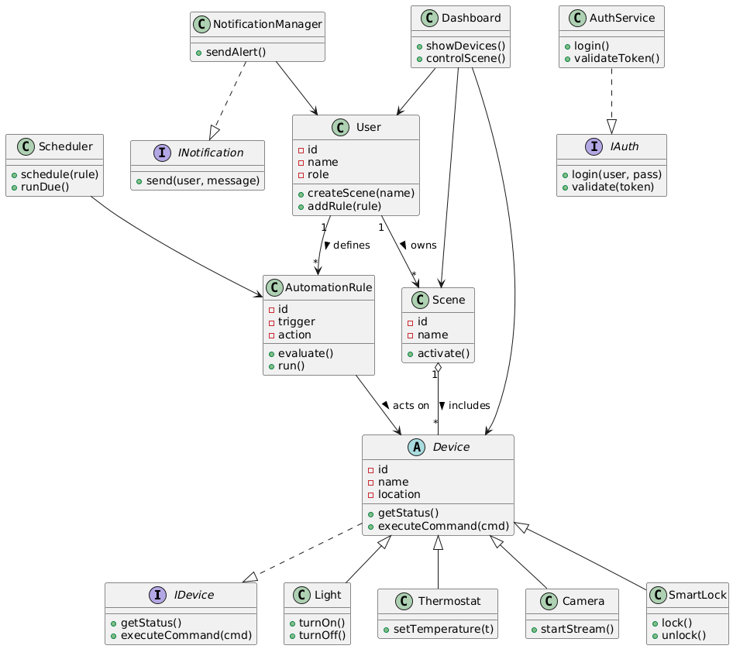

1. **Sequence Diagram:**

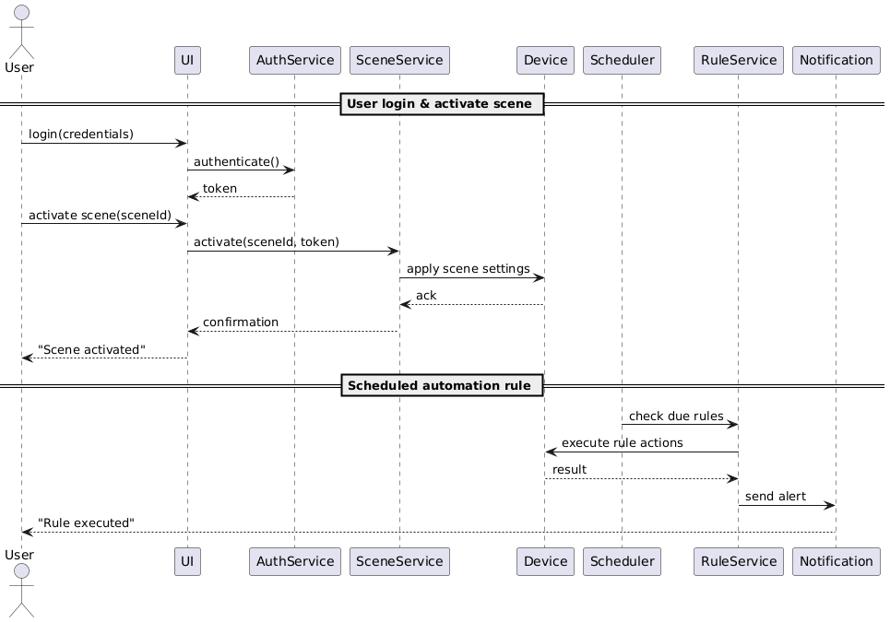

1. **UseCase Diagram:**

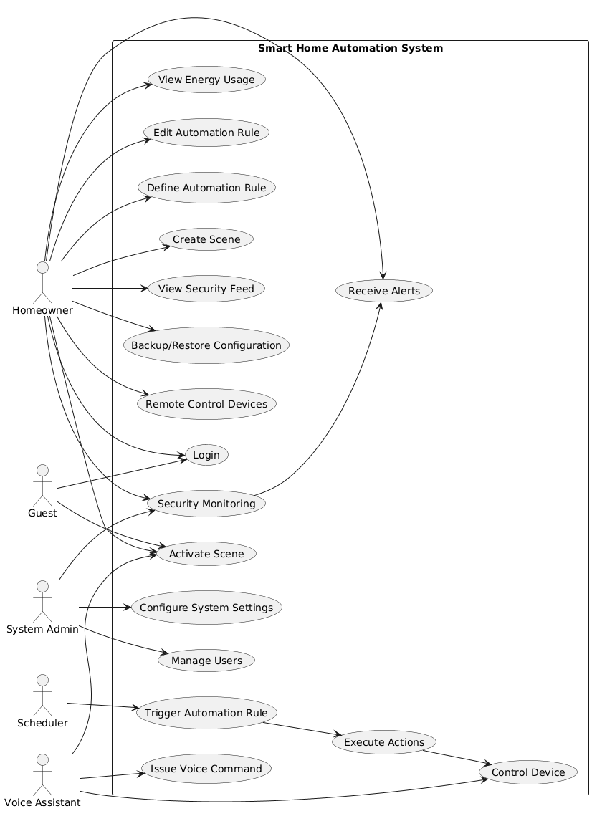

1. **ERD Diagram:**

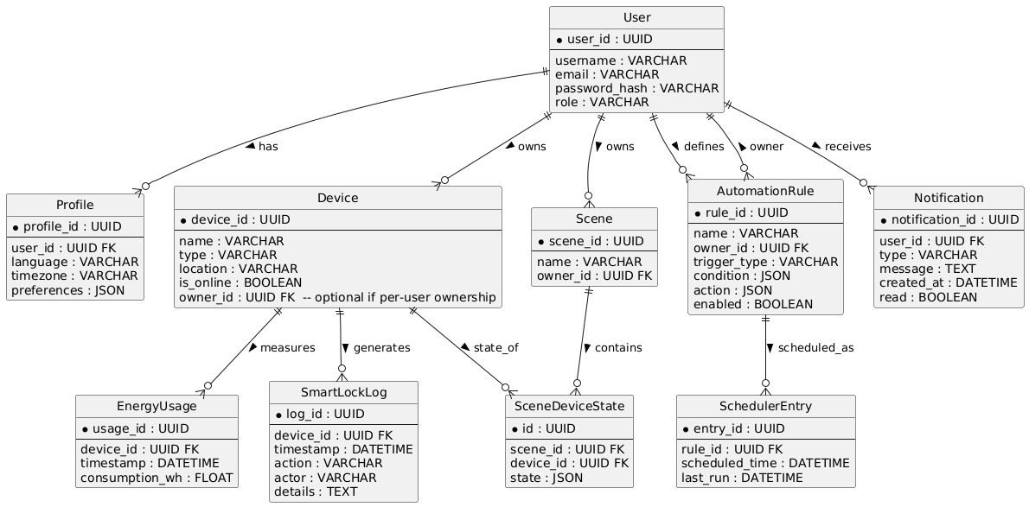

1. **Prototypes:**

**Lo-fi Prototype:**

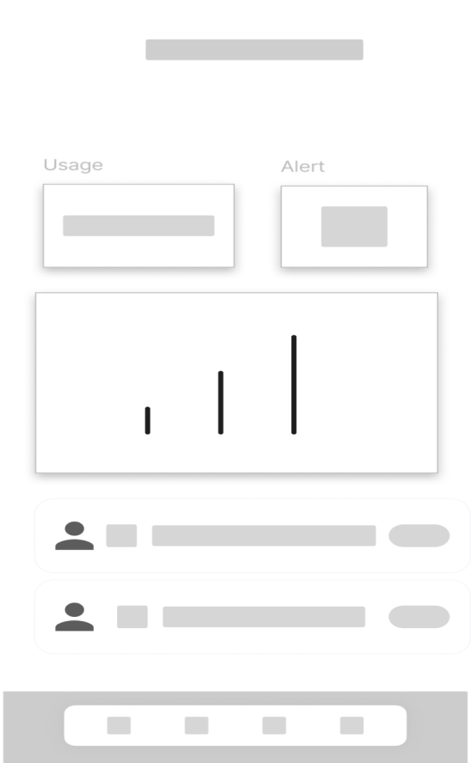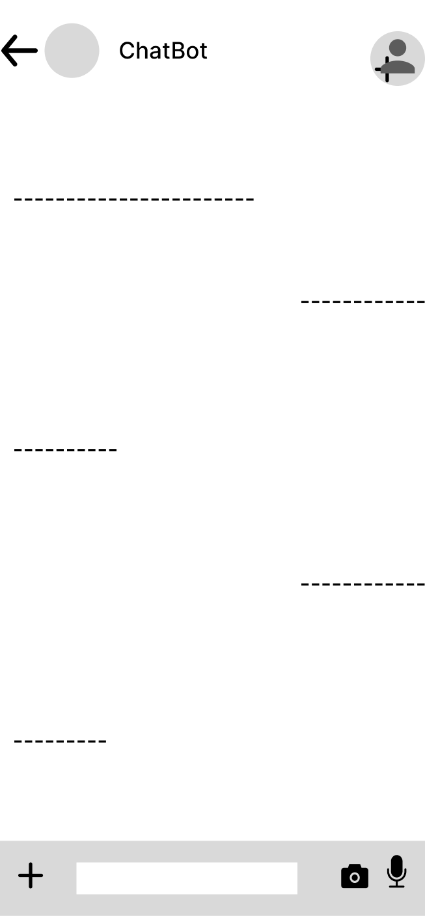

**Hi-fi Prototype:**

